1.Create Child Table (emp)
CREATE TABLE emp(
empno INTEGER PRIMARY KEY,
empname VARCHAR(20),
deptno INTEGER,
empsal INTEGER
);
DESC student;
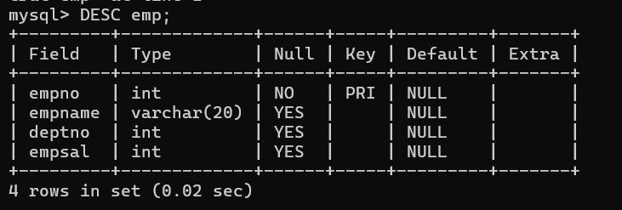

2. Insert Data into emp Table
INSERT INTO emp VALUES(1,'Ram',5,20000);
INSERT INTO emp VALUES(2,'Shyam',6,30000);
INSERT INTO emp VALUES(3,'Ganesh',7,40000);
SELECT * FROM emp;
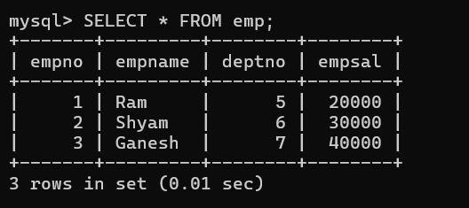

3. Create Parent Table (dept)
CREATE TABLE dept(
deptno INTEGER PRIMARY KEY,
dname VARCHAR(10),
loc VARCHAR(5)
);
Insert Data into dept Table
INSERT INTO dept VALUES(5,'IT','hyd');
INSERT INTO dept VALUES(6,'sales','bglr');
INSERT INTO dept VALUES(7,'Manager','mumb');

SELECT * FROM dept;
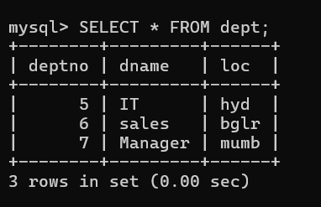

4.Add Foreign Key Constraint
ALTER TABLE emp
ADD CONSTRAINT fk
FOREIGN KEY(deptno) REFERENCES dept(deptno);

5. Test Constraint (Error Case)
INSERT INTO emp VALUES(8,'Ram',8,50000);
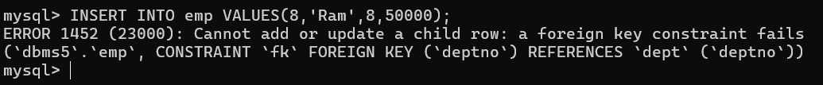

6. Drop Foreign Key Constraint
ALTER TABLE emp DROP CONSTRAINT fk;
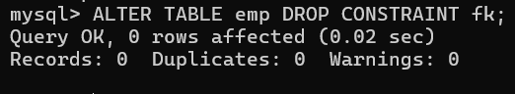

7. Insert Data After Dropping Constraint
INSERT INTO emp VALUES(8,'Ram',8,50000);


8. Final Display
SELECT * FROM emp;
SELECT * FROM dept;
